Execrise 1:

The ip address is 20.225.32.183 and we can see we have only one domain hosted on it from yougetsignal website.

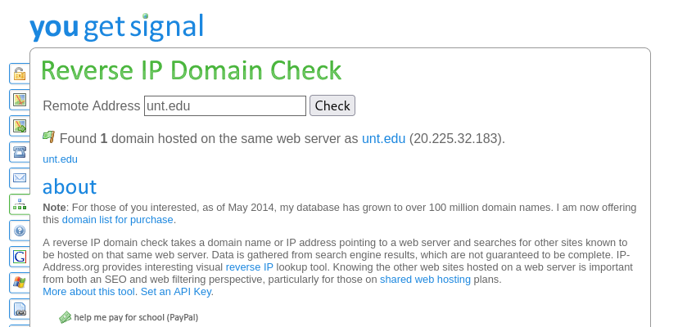

From spiderfoot:

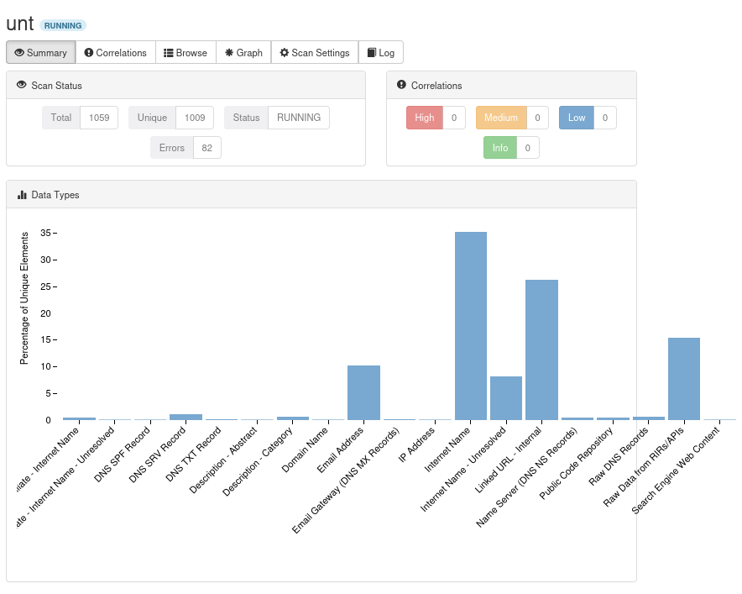

From maltego:

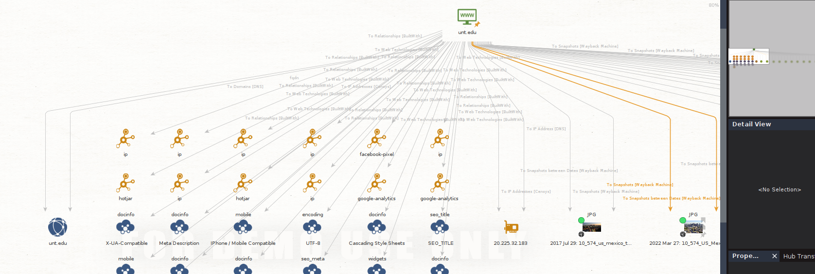

From the results we can the different things, The University of North Texas (UNT) server structure is a complex and distributed system that supports a wide range of services for the university community, including students, faculty, staff, and alumni. The server structure is designed to be highly scalable and reliable, and to provide a high level of performance for all users.

Execrise -2:

Unt.edu : we have 3 domains and 2252 sub-domains.

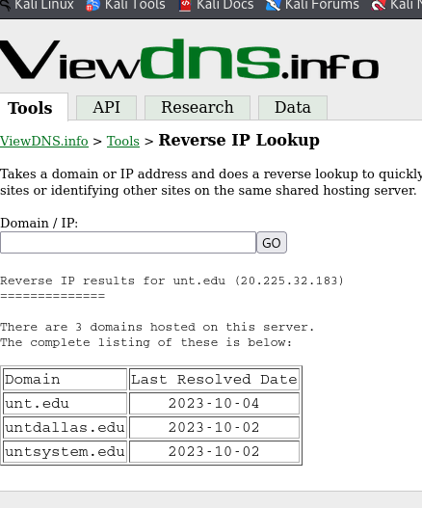

Sub-domains:

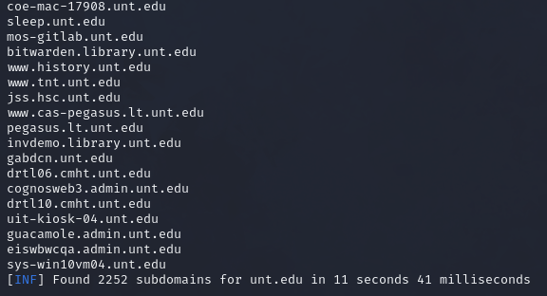

Nsa.gov: we have 1 domain and 48 sub-domains

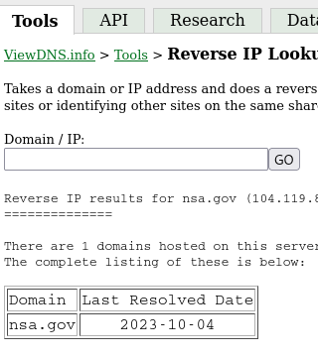

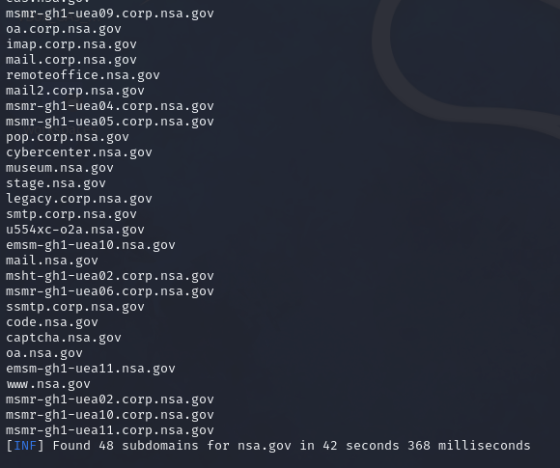

Nasa.gov : we have 5 domains and approx. 7000 sub-domains

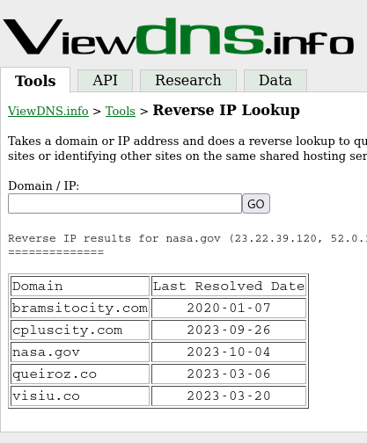

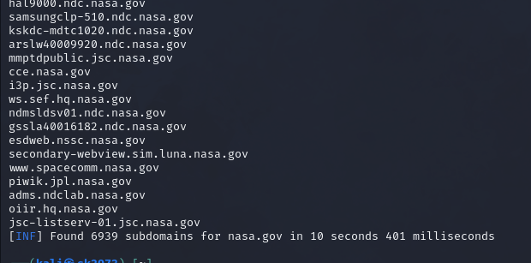

Execrise 3: Dns report : we have 2 name servers for unt.edu

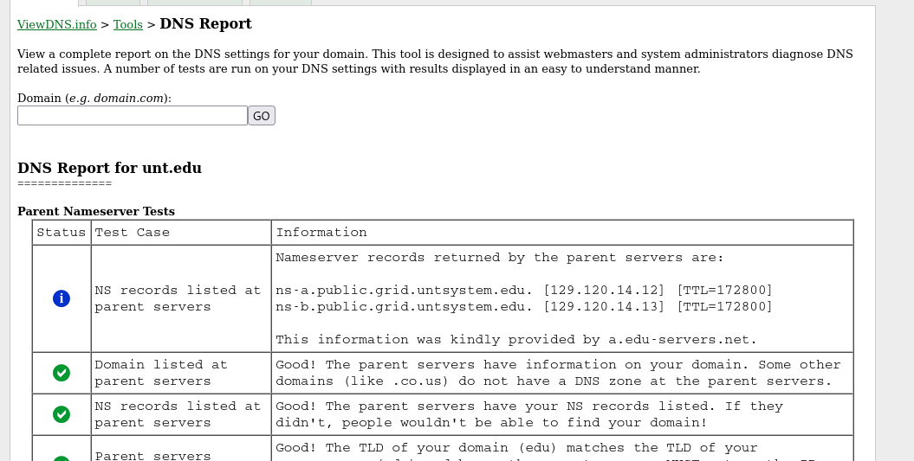

Dns record lookup: But from record lookup we can see more regarding the unt dns.

